**1) Project Title**

The Periwinkle Bookstore

**2) Group Member Names**

Austin, Ron, Steven

**3) Project Description (at least one page in length)**

We are going to be creating a novelty bookstore which specializes in the classics of the 20th century. It will be a hybrid between a typical bookstore and a library, where users can pay a fee in order to rent out books. There will be a comprehensive online database where customers can search for books, rent them out, or add them to their wishlist. They can also leave reviews for the books for other users to see. Users can sign up, login, and contribute to the discussion.

**4) Three features in your project- explain each feature in detail and include what a tier 1, tier 2 and tier 3 of each feature would be.**

There are a few main features that we plan to include. The first is an interactive search page that uses predictive searches in order to come up with a list of books that the users want to read. In order to get to tier 3 status, we plan on using sophisticated Front and frameworks such as Ajax in order to auto complete or auto suggest items. The second feature is the additional security and validation that users must go through in order to register. We plan on using things such as captcha and validation to make sure that values are secure, and we plan on use using hashes in order to make sure that passwords are not stolen in the event of data breaches. The next future we have is the sign in portal, that will allow users to leave a review on various books. In order to get this to a tier 3 future, we plan on introducing a chat room like system. Finally, we will also have an administrative portal where additional crowd operations can be performed, such as deleting users or reviews. The review system also be brought to tears three when we integrate content loading; for example, they will be able to see additional content such as pictures, or upload their own pictures when creating review.

**5) Tools that will be used in the project (technical features such as languages, database, etc.)**

Tools: Python for getting all the book information from good reads, HTML, CSS, JavaScript, C-sharp, bootstrap, SQL, Ajax, and potential he some other frameworks.

**6) Database design (ER diagram)**

The database design is fairly simple. It will incorporate users, rentals, wish list, reviews, and finally books. Here's the best diagram that we have created so far.

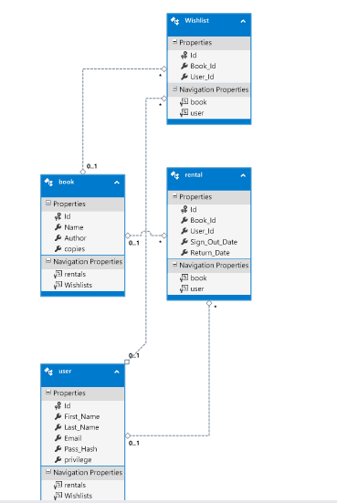

**7) Layout/Master page design (screenshot)**

The layout of the design is fairly straightforward. We plan on using the search page is our homepage. Anybody who comes to the website I can see a list of books based on what they search, and they can also view the results of the reviews. Then, if they login, they have additional options of adding books to their wish list, renting them out, or return them, but this will all be additional features with in the search page itself. They can also go to the chat room. And they can also leave their own reviews.

**8) Role and responsibilities of each team member**

Austin will be responsible for styling and developing the front and webpages. Steven will be responsible for generating in maintaining the database. Ron will be responsible for overlooking the models, controllers, and making sure that the functionality is there.

**9) Project Time line (Gantt chart)**

Week one – generate the database, and the corresponding models and controls.

Week two – add functionality to the views and implement the features.

Week three – continue to work on the functionality to get it to tier 3 status.

Week four – revise and style everything so it looks presentable.